Baikonur Cosmodrome Tour
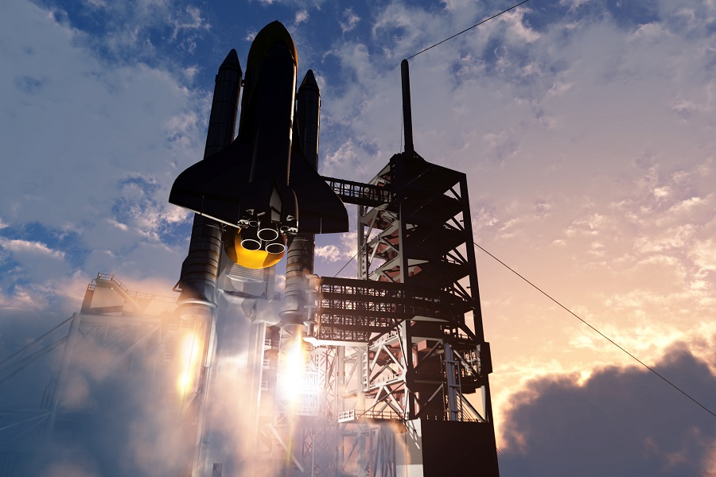
4 days
Every day
Availability: 1-16
Age: Min 18
Baikonur cosmodrome tour is a special trip. It was only 25 years ago when it was a closed military town, and today there is a great opportunity to learn about the history of the astronautics, see the samples of real missiles, spaceships and meet the people whose all life is about and around the space.
This small trip consists of two parts: visit to the city of Baikonur and the museum of history of astronautics and visit to the Baikonur space center itself. There you can see launching platforms and hangars that were the goal of the US secret services as well as the museum of astronautics with the real space shuttle Buran where you can try to take the hold of controls.
Baikonur tour will gift you lots of bright impressions and make the space a bit closer to you.
Booking conditions: Tour needs to be booked and prepaid 2 months in advance
Please note that the tour will take place at a secure zone. Unlike our cultural tours, Baikonur tour does not have a flexible schedule. The timing is set by Russian Cosmos State Agency; based on space ship launch schedule, all visits during the tour will be timed and tour participants are expected to follow. Although not expected, there is a possibility of unforeseen changes by the State Agency that might affect the length and the list of sights included in the program of the tour.
Space ship launch dates are subject to change by Russian Cosmos State Agency. If the schedule changes and new dates do not suit you, we will reimburse tour payment.
Price Currency | USD
Destinations | Almaty, Baikonur city, Baikonur cosmodrome
Offered | Any time
Deadline | Get confirmation 2 months before the departure date
Included | - All transfers;  - Accommodation based on twin room sharing, breakfasts included;  - Sightseeing tour program as per itinerary with English-speaking guides/translators;  - Entrance fees to sights as per itinerary;  - Economy class ticket for flight Almaty – Kyzyl-Orda – Almaty/Nur-Sultan;  - Full-board;  - Permission to visit Baikonur cosmodrome;  - Permission to photograph objects as per itinerary;  - Tour assistant to accompany travellers from Almaty.
Excluded | - Hotel charges for additional services;  - Kazakhstan visa support letter and visa fee;  - Travel insurance;  - International flight tickets before and after the tour.
Accommodation | Central Hotel or similar local 2* or 3* hotel

Itinerary

Day 1.
Take flight to Kyzyl-Orda from Almaty. On arrival you will be met and transferred to Baikonur (240 km, 3 h). Overnight at the hotel.
Meals: dinner

Day 2.

Today you will explore the city of Baikonur. Meet your guide at the hotel lobby to start touring around the area full of living history. Visit the Museum of Baikonur Cosmodrome History, memorial to rocketeers, Yuri Gagarin monument and local squares. Stop at Soyuz rocket model. Overnight at the hotel.
Meals: breakfast, lunch, dinner

Day 3.

Today you will see off spacemen coming out of the Cosmos Hotel and follow the crew to Baikonur Cosmodrome (40 min, 30 km). Visit memorial houses of Yuri Gagarin, the first man in space, and Sergei Korolev, pillar of practical astronautics and lead Soviet rocket engineer during 1950-1966. Visit Baikonur Cosmodrome Museum and Buran spacecraft where you can try the cosmonaut’s seat. We will then move to assembly complex to watch the space crew reporting to the State Commission. The highlight of this day will be watching the launch of space craft Soyuz from legendary “Gagarin Start” also known as Site №1 (observation deck is located 1 km from the launch site). Transfer back to the hotel for overnight.
Meals: breakfast, lunch, dinner

Day 4.

Check-out from the hotel till noon. Transfer to Kyzyl-Orda for flight to Almaty/Nur-Sultan. End of the tour.
Meals: breakfast

