Ortar and Turkestan Day Tour
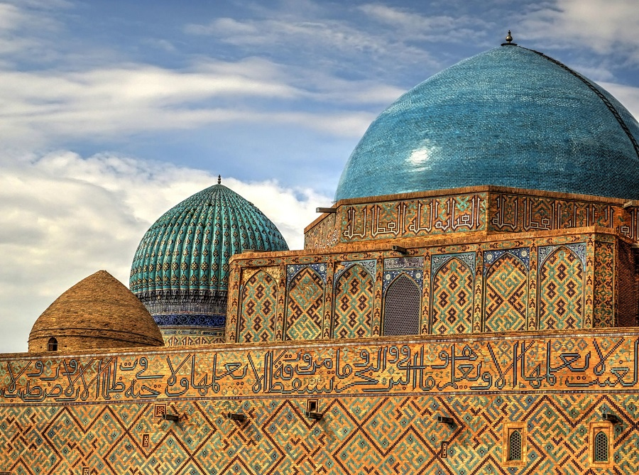Ortar and Turkestan Day Tour
One-day tour to ancient cities of Kazakhstan is the best opportunity to learn medieval history of this land, see its rich architecture. Here you will visit archeological excavations, The History Museum of Otrar, architectural complex in Turkestan and other sights.
Price Discount | 1 person – no discount  2 persons – 10% discount  3 persons – 20% discount  4 persons and up – 30% discount
Price Currency | USD
Destinations | Arystan -Baba Mausoleum, Museum, and excavations of Otrar town, Turkestan, Hazrat Sultan archaeological complex, Khoja Ahmed Yasawi Mausoleum
Offered | Any time
Deadline | Get confirmation 3 days before the departure date
Included | - Guided sightseeing tour;  - Entrance fees to the museums, mausoleums and other sights;  - Transport throughout the city tour.
Excluded | Travel insurance.  Tips are not included, but would be appreciated;
Accommodation | N/A

Must visit on your Ortar and Turkestan Day Tour
Our guide and driver will meet you at your hotel in Shymkent. Your unforgettable journey to the history starts with a drive to Shaulder Village in Otrar region. There you will visit Arystan-Bab Mausoleum and archaeological site of the ancient settlement of Otrar. The next place to pay a visit to is the city of Turkestan, one of the most ancient cities not only Kazakhstan but also in Central Asia. Turkestan was founded in 490 AD on the crossroad of trade routes from Samarkand, Bukhara and Khiva to the northern Kazakhstan. In the Middle Ages Turkestan was the administrative, political and religious center of Central Asia. During 16th – 18th centuries it was the capital of Kazakh khanate. You will visit “Azret-Sultan” historical and architectural complex, Khoja Ahmed Yasawi Mausoleum and Turkestan ancient settlement, where you will feel like you have been transferred back in time. You will be driven back to the hotel full of impressions form your short but intense journey.
Duration of sightseeing tour: 8-9 hours.

Itinerary
Day 1: Arystan -Baba Mausoleum, Museum, and excavations of Otrar town, Turkestan, Hazrat Sultan archaeological complex, Khoja Ahmed Yasawi Mausoleum

Our guide and driver will meet you at your hotel in Shymkent. Your unforgettable journey to the history starts with a drive to Shaulder Village in Otrar region. There you will visit Arystan-Bab Mausoleum and archaeological site of the ancient settlement of Otrar. The next place to pay a visit to is the city of Turkestan, one of the most ancient cities not only Kazakhstan but also in Central Asia. Turkestan was founded in 490 AD on the crossroad of trade routes from Samarkand, Bukhara and Khiva to the northern Kazakhstan. In the Middle Ages Turkestan was the administrative, political and religious center of Central Asia. During 16th – 18th centuries it was the capital of Kazakh khanate. You will visit "Azret-Sultan" historical and architectural complex, Khoja Ahmed Yasawi Mausoleum and Turkestan ancient settlement, where you will feel like you have been transferred back in time. You will be driven back to the hotel full of impressions form your short but intense journey.
Duration of sightseeing tour: 8-9 hours.

