Horse Riding Tour in Mountains
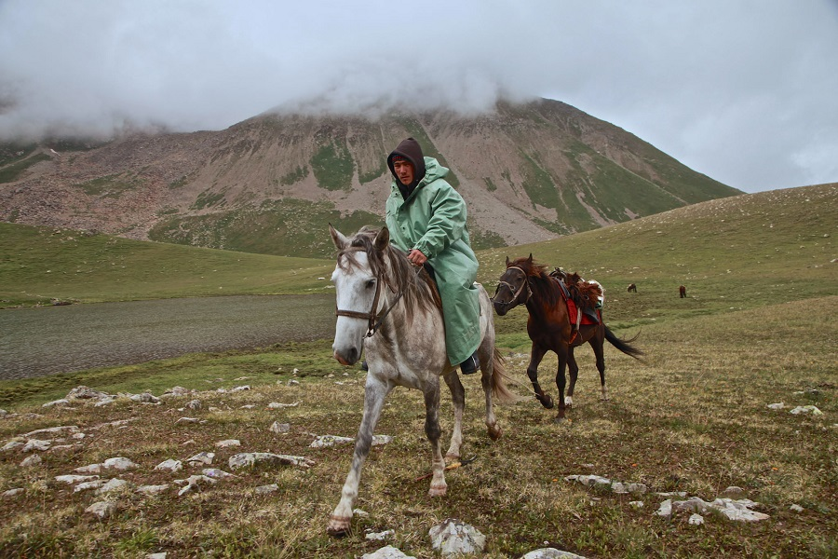Horse Riding Tour in Mountains
A 11-day Horse Riding Tour in Mountains is designed for skilful riders. Horse riding in alpine places in the south of Kyrgyzstan is ahead of you. The program plans the visits of picturesque places: Gorge Chichkan, Sary Chelek Lake.

Horse Riding Tour in Mountains descriptions
Price Currency | USD
Destinations | Bishkek, Chichkan, KaraSuu, Sary-Chelek, Toktogul
Offered | Any time
Deadline | Get confirmation 3 days before the departure date
Included | - Twin room accommodation including early check in on Day 1;  - Meals – groups 1-4 people – as per program; groups 5-10 people – full board;  - Transportation through out the whole trip;  - English Speaking Guide;  - Sightseeing tour program in all cities according to the program, including entrance fees to sights, museums, Karakol National Park. Camera/video fees are not included and paid separately;  - Rent of kitchen equipment and tents, mat;  - Cook’s services;  - Horses;  - Stableman.
Excluded | - Visa support;  - Hotel charges for additional services;  - Single supplement;  - Accommodation in a single tent;  - Sleeping bag;  - Consular fees paid upon collection of the entrance visa to Kyrgyzstan;  - International airfares;  - Tips are not included, but would be appreciated;  - Personal insurance and items not mentioned above.
Accommodation | N/A

Itinerary
Day 1: Bishkek
Arrival in Bishkek. Transfer to the hotel. Sightseeing tour: Oak Park, Ala -Too Square, Philarmonic hall, Statue of Manas, Victory Square. Overnight in the hotel.
Meals:
Day 2: Bishkek – Chichkan.
Transfer from Bishkek to Chichkan (320 km) via Ala-Bel Pass (3184 m above sea level). Transfer via Suusamyr valley (2200 m above sea level). This valley is one of the most beautiful jailoo (pasture) in the country. The road goes through magnificent landscapes and blooming alpine meadows. Lunch and dinner in a local cafes. Short walking in the gorge. Overnight at the hotel.
Meals: Breakfast
Day 3: Chichkan – Kara-Suu
After breakfast transfer to Kara-Suu village (260 km). This road connects North and South of Kyrgyzstan. The village is located in Jalal-Abad region. The road to the village (20 km) will go along Kara-Suu river. Lunch, dinner and overnight at home stay. Walking in the village and getting acquainted with culture and life style of local people.
Meals: Breakfast/Lunch/Dinner
Day 4: Horseback riding from Kara Suu village – Aksak Koi Pass
After breakfast meeting with a staff who will accompany you during the tour. Riding along the Kara-Suu river towards mountains. On the way you will see a waterfall. Picnic near Kara-Suu lake. After lunch riding to the foot of Aksak-Koi Pass (1600 m above sea level). This route will go through the very beautiful places. On the way you will pass yurts of local shepherds and you will have a chance to talk to them and get acquainted with a life style of shepherds. Dinner and overnight in the tents.
Meals: Breakfast/Lunch/Dinner
Day 5: Makmal Pass
After breakfast riding via Makmal Pass (2460 m above sea level). Picnic. After lunch and rest riding to the Northern shore of the Sary-Chelek lake. The Sary-Chelek lake (“yellow cup” in Kyrgyz language) is located on the territory of the natural park “Sary-Chelek” in the South-East slope of Chatkal range which is located in the Western Tien-Shan. The height of water's edge is 1878 m above sea level. The Sary-Chelek lake is a heart of the nature reserve. It draws your eyes and does not leave anyone indifferent to its beauty. The fauna and flora of the nature reserve is very rich and various. There are 300 types of plants, 32 types of trees, 80 types of bushes, 38 species of animals, 157 species of birds. Animals – reindeers, wild boar, wolves, wild cats, foxes, marmots, porcupines, etc. Birds – pheasants, hawks, eagles and many others. Camping not far from the Sary-Chelek lake. Dinner and overnight in the tents.
Meals: Breakfast/Lunch/Dinner
Day 6: Ashuu Pass
After breakfast riding via Ashuu Pass (2760 m above sea level). Picnic on the Pass. There could be a chance to see griffons and eagles. After lunch and rest riding to Chogoloi. Dinner and overnight in the tents.
Meals: Breakfast/Lunch/Dinner
Day 7: Sary Kamysh valley
After breakfast riding to the Southern shore of the Sary-Chelek lake. Picnic. After lunch riding through 6 lakes: Toz-Kol, Kyla-Kol, Iyri-Kol, Choilok-Kol, Churok-Kol. Aram-Kol. Camping at Sary-Kamysh valley. Dinner and overnight in the tents.
Meals: Breakfast/Lunch/Dinner
Day 8: Kara-Suu village
After breakfast riding to Kara-Sull village. The route goes through walnut forest. Lunch, dinner and overnight in home stay.
Meals: Breakfast/Lunch/Dinner
Day 9: Kara-Suu – Toktogul
After breakfast transfer to Toktogul. Lunch on the way. On the way you will be passing one of the most beautiful reservoirs in Central Asia, Toktogul, that funnels the gorgeous Naryn River into a hydroelectric station.
Family run accommodation.
Meals: Breakfast/Lunch/Dinner
Day 10: Toktogul – Bishkek
After breakfast transfer to Bishkek. You will drive over the Kalmak-Ashu gorge through a beautiful Suusamyr valley. Great view is guaranteed. Overnight at the hotel. Farewell dinner.
Meals: Breakfast/Dinner
Day 11: Bishkek – airport
In the morning transfer to Bishkek. Departure.
Meals: Breakfast

